Assignment 2: Tabular Q-Learning on Taxi-v3

1. Introduction
Tabular Q-Learning is implemented in the Taxi-v3 environment in this assignment. The goal is to teach an agent how to efficiently pick up a passenger and transport them to the right location while avoiding as many penalties as possible.
Taxi-v3 contains:
- 500 discrete states
- 6 actions (move directions, pickup, drop-off)
- Reward structure:
  - −1 per step
  - +20 for successful drop-off
  - −10 for illegal pickup/drop-off
The Q-Learning update rule used is:
$$Q(s,a)←Q(s,a)+α\left[r+γ\underset{a^{'}}{max⁡}Q(s^{'},a^{'})-Q(s,a)\right]$$
where α is the learning rate, γ is the discount factor, and ε controls exploration through an ε-greedy policy.
The agent was trained for 10,000 episodes, and performance was measured using:
- Average return per episode
- Average steps per episode
- Moving averages (window = 100) to visualize convergence
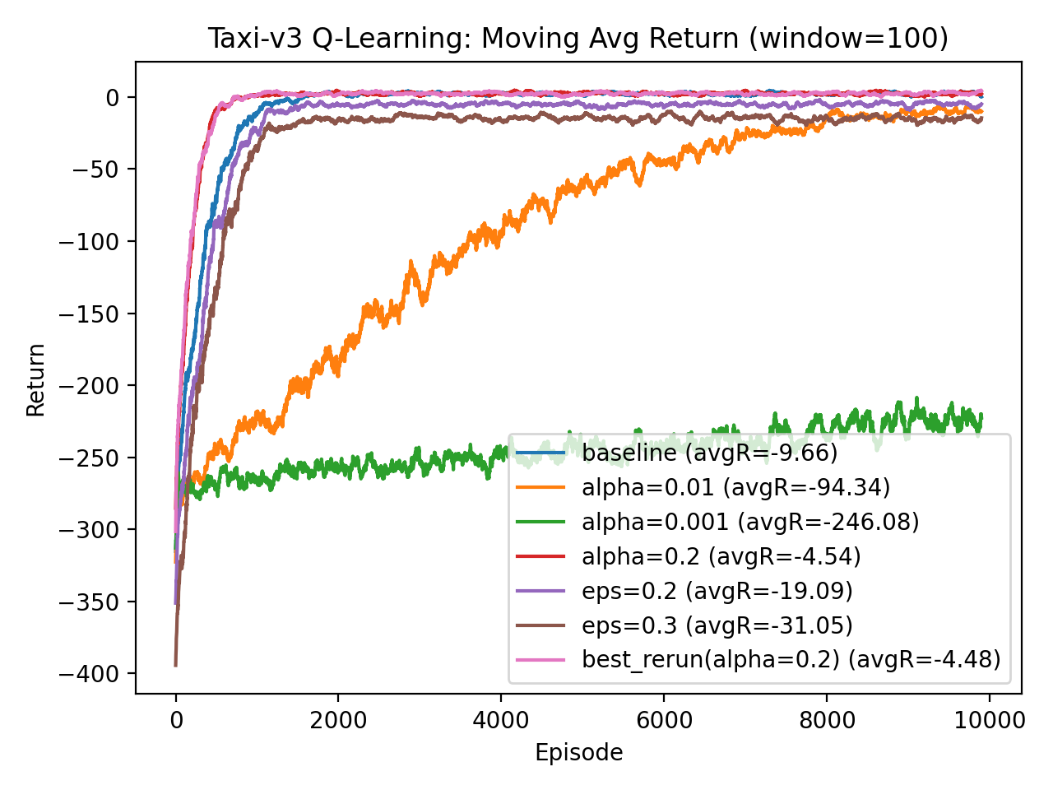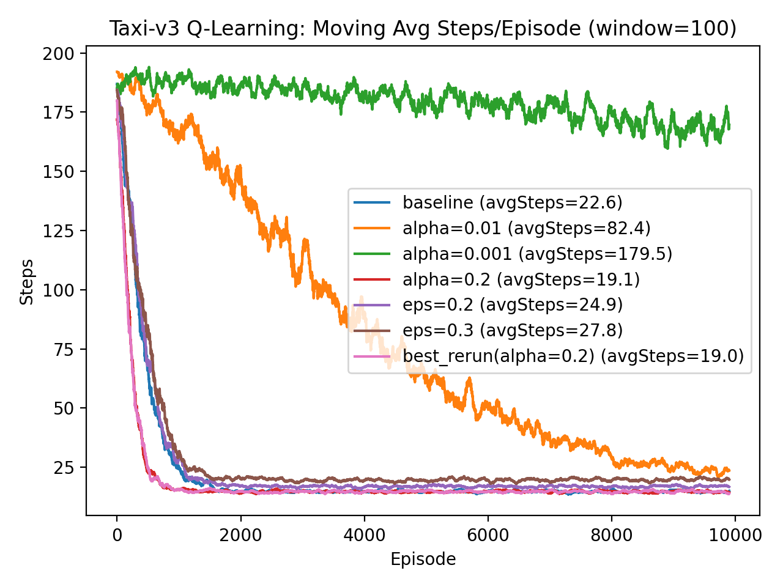

2. Baseline Configuration
The baseline hyperparameters were:
- α = 0.1
- ε = 0.1
- γ = 0.9
Baseline Results
- Average Return: −9.66
- Average Steps per Episode: 22.6
The plots quickly get better during the first 1,000 episodes. As the agent learns to avoid wandering and needless penalties, steps drop significantly from about 180 to about 20. Nevertheless, the ongoing exploration (ε = 0.1) and the persistent −1 step penalty result in a somewhat negative average return.

3. Learning Rate (α) Experiments
The learning rate was varied independently while keeping ε and γ fixed.
α = 0.01
- Avg Return: −94.34
- Avg Steps: 82.4
Learning improves slowly because Q-values update in very small increments. Convergence is delayed.
α = 0.001
- Avg Return: −246.08
- Avg Steps: 179.5
Learning is extremely slow. The agent fails to meaningfully improve within 10,000 episodes due to negligible updates.
α = 0.2
- Avg Return: −4.54
- Avg Steps: 19.1
This configuration achieved the best performance. Larger updates allow faster propagation of reward signals, accelerating convergence without causing instability.
Analysis of α
- Very small α → slow convergence
- Moderate α (0.1–0.2) → stable and efficient learning
- α = 0.2 provided the best balance between speed and stability

4. Exploration Rate (ε) Experiments
Exploration was varied independently.
ε = 0.2
- Avg Return: −19.09
- Avg Steps: 24.9
Higher exploration increases randomness, leading to more penalties and longer episodes.
ε = 0.3
- Avg Return: −31.05
- Avg Steps: 27.8
Further increase in exploration reduces performance significantly. Excessive exploration prevents the agent from exploiting learned optimal actions.
Analysis of ε
- Moderate ε (0.1) balances exploration and exploitation
- High ε increases variability and reduces performance
- Performance declines as exploration increases

5. Best Configuration and Re-run
The best configuration was selected based on:
- Highest average return
- Lowest average steps
Best configuration:
- α = 0.2
- ε = 0.1
- γ = 0.9
Re-running this configuration produced:
- Avg Return: −4.48
- Avg Steps: 19.0
The re-run confirms consistent performance and stable convergence.

6. Plot Interpretation
Return Plot
- Rapid improvement early in training
- Convergence around episode 1,000
- α = 0.2 converges fastest and reaches highest steady performance
- Small α values fail to converge effectively
Steps Plot
- Initial episodes require ~180 steps
- Converges to ~15–20 steps
- α = 0.2 achieves the lowest steady-state steps
- Higher ε values plateau at higher step counts due to randomness
Both plots clearly demonstrate learning progression and hyperparameter sensitivity.

7. Discussion
The results align with Q-Learning theory:
- Learning rate controls convergence speed. Too small slows learning; moderate values accelerate convergence.
- Exploration rate controls randomness. Excessive exploration degrades performance after learning stabilizes.
- The selected configuration achieves near-optimal efficiency with minimal unnecessary actions.
The agent successfully learns a near-optimal policy, reducing episode length and improving reward significantly compared to early training.

8. Conclusion
This implementation demonstrates successful application of tabular Q-Learning to Taxi-v3.
Key findings:
- Learning rate significantly impacts convergence.
- Exploration must balance discovery and exploitation.
- α = 0.2 and ε = 0.1 produced the best performance.
- The agent converges to approximately 19 steps per episode.
The results validate theoretical expectations regarding hyperparameter influence on Q-Learning performance.

